Scenario: Workplace Specific – Coffee Counter

General Procedure
Set up the simplest interaction (shortest phrases that do the job) and ask the learner to play the role of the employee.
- Play the role of the guest.
- Praise the learner's efforts.
- Vary the interaction as needed
- Make sure to review this interaction at subsequent meetings if work is still needed.

Note: blank lines and underlined words indicate that you can model the different elements that could go there.

Interaction: Taking Orders

Useful phrases

May I help you?
Have you been helped?
May I take your order?
What is the name for the order?

The total is _________dollars and ____ cents.
That will be _____$ 5.50, 7.25, 2.75.

Phrases needed to clarify order:
Did you say large or small?
Did you say______?
I’m sorry, could you repeat that?

Understanding orders said rapidly:
For this type of work, it is essential that the learner hears many variations on the ways that people order. The focus here is listening comprehension and strategies for clarification. Role play various interactions with complications.

What the customer might say: (This will help you in planning roleplays)
Small coffee with non-fat milk.
Large black coffee.
Medium latte.
Small cappuccino room temperature.
Two croissants, please.
One large coffee and one low fat latte.
Two danishes and one medium coffee.
Where is the cream?
Where are the napkins?
Where is the sugar substitute?
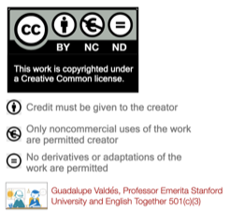
I need two sugars please.
Is my order ready?
You made a mistake. I didn’t order a _______, I ordered ________.

Interaction Examples:
- Normal easy order– no complications.
- Order with some complications (lots of details).
- Order with questions on other items.
- Mistaken order and customer complaint.

