Scenario: Workplace Specific -Working at a Restaurant

General Procedure
Set up the simplest interaction (shortest phrases that do the job) and ask the learner to play the role of the employee.
- Play the role of the guest.
- Praise the learner's efforts.
- Vary the interaction as needed
- Make sure to review this interaction at subsequent meetings if work is still needed.

Note: blank lines and underlined words indicate that you can model the different elements that could go there.

Interaction: Taking Orders

Useful Phrases
May I take your order?
What can I get you?
What would you like?
Would you like some water?
Would you like to hear the specials?
How would you like that cooked?
The ____ comes with ____________.
Would you like the ____ or the _____ with that?
I am sorry but there are no substitutions.
I am sorry. I will take it back to the kitchen.
Is there anything else I can get you?
I’m sorry, we are out of _____________.

Interaction Examples:
- Taking an order at a fast food restaurant.
- Taking an order at a sit down restaurant.
- Waiting on a table and responding to additional requests.
- Waiting on a table with complications, errors, and problems.

Procedure for hearing more examples
If you think it is useful, try this:
- Let's watch these videos and then let's practice the interaction.
- Notice similarities and differences.
- Let's pick out the key phrases that you need to use and to understand.

Youtube Videos:
This video can be used for listening comprehension. It covers various types of restaurants as well as phrases used in interaction with a waiter. English is easy to follow.
https://youtu.be/I6lArkT15l8

Share the following videos. Some are very basic, but repeat useful language.
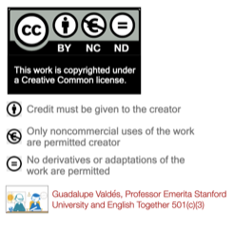
https://youtu.be/-cg3nPzVOSs
https://youtu.be/bgfdqVmVjfk
https://youtu.be/aC3yimIoTfI

