Scenario: Everyday Living: Asking For Directions/ Giving Directions

General Procedure
Set up the simplest interaction (shortest phrases that do the job) and ask the learner to play the role of the person answering the questions.
- Play the role of the person asking the questions.
- Praise the learner's efforts.
- Vary the interaction as needed
- Make sure to review this interaction at subsequent meetings if work is still needed.

Note: blank lines and underlined words indicate that you can model the different elements that could go there.

Scenarios (you can describe the context in which this need might arise)
Ask the learner to participate with you in unscripted interactions (role plays) in which s/he is asking for directions/giving directions.
- Asking for directions to a school.
- Asking for directions to the nearest grocery store.
- Giving directions to the nearest gas station.
- Asking for directions to a specific address (street and number).

(Remember: You are the most valuable resource when you model the phrases needed to do the job.)

Useful Phrases

“Excuse me, could you help me find ______ ?” (the library, 205 Washington Street)

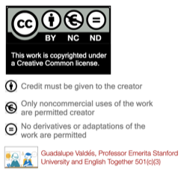
“Excuse me. How do I get to _______ please?”(Green Oaks School, Downtown San Francisco, the Bart station)
“Excuse me. Where’s the nearest _____ please?” (grocery store, restroom, gas station, post office, police station)
“Excuse me. I’m looking for the Number _____ bus stop.” (45, 36)
“Excuse, I am looking for the UPS store.”
“It’s straight ahead.”
“Go down ____(Maple, El Camino, California) street two blocks and then turn ____ (right, left)”
“It’s the_____ (first, second) building on the _____(right, left)”
“Go three blocks and then turn right.”
“Go one block and then turn left.”

Directions to a nearby town by freeway.
“Take highway ___(101 north, south).”
“Go to California 237 Exit and turn _____(right, left)”
“Follow 237 to _________(Calaveras Rd, McCarthy Boulevard)”
“You are now in Milpitas.”

